A Study of Strategies for Improving Student Satisfaction in the Context of Blended Learning--Taking China's Sichuan Province as a Case Study

Hao Wei¹
Chinese Graduate School, Panyapiwat Institute of Management, Thailand
E-mail: haowei_cdu@163.com, ORCID ID: https://orcid.org/0009-0003-1877-1815
Received 08/112024 | Revised 12/11/2024 | Accepted 12/12/2024
Abstract
Background and Aim: Under the background of the continuous development of digital education, Blended Learning has become one of the important teaching methods in universities, and the study of its development and reform direction has become a key research topic in university education.
Materials and Methods: This study selected 15 undergraduate students of class 2022-2023 in Sichuan province of China to conduct semi-structured interviews, and used the literature research method, interview method, and content analysis method to analyze the data, collate, summarize, and distill themes.
Results: The study identified three primary strategies to improve student satisfaction in blended learning: (1) enhancing platform stability, usability, and content relevance to provide a seamless learning experience; (2) aligning course content, instructional methods, and learning outcomes with students' expectations and career goals; and (3) focusing on instructional design by improving teachers' ability to employ technology effectively and applying diversified evaluation methods. These strategies collectively contribute to an enhanced perception of quality, which was found to have the most significant impact on student satisfaction.
Conclusion: This study highlights the importance of a high-quality online learning platform, alignment with student expectations, and the perceived quality of instructional design in influencing blended learning satisfaction. Universities should prioritize building technically supportive platforms, offering continuous faculty development, and utilizing multi-dimensional evaluation models to address students' diverse needs effectively. By implementing these strategies, institutions can strengthen blended learning effectiveness, improve student satisfaction, and better meet educational goals in a digital learning environment.
Keywords: Blended Learning; Satisfaction; Platform Quality; Expected Quality; Perceived Quality

Introduction
With the rapid development of information technology and the continuous innovation of the global education model, Blended Learning, as an education model that combines the advantages of online and offline teaching, has become an important development trend in the field of higher education. The Blended Learning mode aims to realize the diversification of teaching content and flexibility of teaching methods by combining traditional classroom teaching and modern online teaching resources to meet the needs of different learners. With the advancement of educational informatization, the Blended Learning mode has also been adopted by more and more colleges and universities as an important part of teaching reform.
In recent years, many universities have increased their investment in Blended Learning, providing training and support to help students and teachers better use online education or Blended Learning. The rapid growth has also forced universities to start rethinking their teaching models and how to more actively explore the direction of blended education (Chai, 2021). This trend is expected to provide students with a more flexible, personalized, and adaptive learning experience to meet the current challenges in an environment of rapid knowledge updating and proliferation of access channels and to present new possibilities for future educational reform and development (Liu, 2023). Through the study of more than one thousand academic papers in a decade, it is found that blended learning research has become the trend and hotspot of research in China in the last decade. However, at the same time, new challenges come along. As a teaching method that is not entirely constrained by space, ensuring the quality of teaching is a key issue. While the online part of teaching often requires high-quality course content, effective interactions, and timely feedback, offline teaching needs to adapt to new teaching environments and consider students' learning needs after online learning. Students' acceptance of this new mode of instruction, their ability to adapt to technology, their expectations of the learning experience, and how satisfied they are ultimately with that mode of instruction may affect the final learning outcomes. They include but are not limited to the curriculum design, the quality of the technology platform, the students' ability to learn independently, the teachers' instructional strategies, and the school's policies and resources, among others. These possible factors interact with each other and together determine the ultimate effectiveness of blended learning.
In this context, studying how to improve satisfaction in blended learning from the student's perspective is a topic of great practical significance and theoretical value.

Objectives
- Study the factors affecting college students' blended learning satisfaction.
- Propose effective strategies to enhance college students' blended learning satisfaction.

Literature review

1. Satisfaction Theory
Scholars for the satisfaction of the research began in the 1970s, the earliest is the “customer satisfaction” related concepts introduced into the business market, his research allows companies to begin to pay attention to the quality of service, and gradually pay attention to the results of the survey of service quality in the market (Cardozo, 1965). In the 1980s, satisfaction theories shifted their focus to service outcomes, placing more emphasis on customers' perceptions of service quality, i.e., their intuitive perceptions of service effectiveness, and scholars and researchers in various regions developed the ACSI model, the ECSI model, and the CCSI model on this basis. In these many satisfaction theory research and discussions, the American Customer Satisfaction (ACSI) is one of the most classic theories, in the marketing of the classic theory of 4C based on the pursuit of customer satisfaction, the requirements of customer satisfaction in the prerequisites to reduce costs, and then take into account the convenience of the customer.
There are six structural variables in the ACSI model, including nine kinds of causal relationships. At the same time, these variables are variables that can be directly measured in the practice process in specific situations, i.e., apparent variables. Therefore, in the data analysis and discussion of the results of these six structural variables, the first half of the four variables, i.e., customer expectation, perceived quality, perceived value, and customer satisfaction, of which CE, PQ, and PV are independent variables, CS is the dependent variable, and customer complaints and customer loyalty are the outcome variables of CS. The ACSI model is designed to be simple and easy to use, and it is regarded as the most influential customer satisfaction index model, which is used in many fields and industries. The ACSI model is designed to be simple and easy to use, is regarded as the most widely influential customer satisfaction model at present, and is used as the basis for the measurement of subject satisfaction in many fields, such as the study of patient satisfaction in the medical field and the exploration of tourists' satisfaction in the tourism industry, and so on. In some European and American countries, the ACSI model theory cited in the field of higher education research has gradually become a new trend and has become an important reference standard for the evaluation and supervision of education quality (Cardozo, 1965).
As scholars from various countries are getting richer and richer in customer satisfaction research results, in the 1990s, Chinese scholars began to increase the research on customer satisfaction, including Tsinghua University as a representative, based on the ACSI model, while optimizing and adjusting the model with China's national conditions, and constructed the CCSI (China Tsinghua University Customer Satisfaction Index) model, which began to be implemented in 2015, and has formed China's first relatively complete customer satisfaction model and caused a certain impact internationally. The CCSI (China Tsinghua University Customer Satisfaction Index) model was constructed based on the ACSI model and optimized and adjusted with China's national conditions and started to be implemented in 2015, thus forming China's first relatively complete customer satisfaction model, and at the same time, it has also caused a certain impact in the international community. Compared with the ACSI model, the CCSI model adds the brand image of the enterprise and takes this variable as the initial variable, which influences the dependent variable, and at the same time, in the result variable of the original ACSI model, the CC variable of customer complaint is deleted, and the result variable points to customer loyalty, which is determined by customer satisfaction, i.e., the CS variable (Liu, 2023).
Applying the customer satisfaction model to different industries, it is necessary to consider the influence of the industry's real-life scenarios on it, to make corresponding changes in some basic concepts or relationship paths (Liu & Yang, 2017). established the CHE-CSI model based on the ACSI model and the CCSI model in combination with the actual situation of Chinese universities, adjusting the structural variables to customer expectations, perceived quality, customer satisfaction, customer loyalty, and customer trust. Retrospectively, domestic education researchers' studies on satisfaction models found that customer satisfaction has a very strong reference in the field of education. Students or learners who receive education are the service objects of education, and they can be regarded as the customers to be served by educational products.
2. Studies related to the influencing factors of satisfaction
Many studies have shown that student satisfaction has become an important influencing factor that affects the learning effect and whether the learning goal is achieved. With the development of Internet technology and the gradual coupling of various types of online and offline education, how to promote students to improve their learning effectiveness has received the attention of relevant scholars and has begun to conduct extensive research. In Blended Learning, the various course resources provided by online learning platforms can be regarded as the services of the platforms to provide knowledge-based products to students, and the whole process of students starting to learn through these platforms until they acquire knowledge can be regarded as a consumption process. Therefore, the theory of customer satisfaction provides theoretical support and a variable design basis for satisfaction in Blended Learning (Wu & Zhang, 2024).
In the 1850s, American scholars introduced the Swedish theory of customer satisfaction into the field of higher education and conducted relevant research on it, creatively putting forward the concept of student satisfaction. The United States is the earliest country in the world to carry out survey research on student satisfaction in colleges and universities, and the survey research has achieved good results in both scientific research and practice. In the 1860s, American scholars designed the Student Satisfaction Inventory (SSI, which is used to carry out large-scale student satisfaction surveys. Among the many surveys of student satisfaction in colleges and universities in the U.S., the most representative is the National Student Satisfaction Study (NSSS), which is a large-scale survey of student satisfaction in higher education that is implemented once a year in the U.S. and releases an authoritative National College Student Satisfaction Report after the end of the survey, which includes the purpose, target, methodology, findings, and recommendations of the survey. Object, survey method, survey results, and recommendations. The assessment not only helps colleges and universities to understand the needs and satisfaction of students, and then targeted adjustment of school construction and teaching; but also for the community to grasp the status quo of higher education to provide a window, so that its objective evaluation and effective supervision, prompting the United States to continue to improve the quality of higher education (Martensen et al., 2000).
The UK's college student satisfaction survey started later, and the University of Limerick conducted the first college student satisfaction survey in 1999. Subsequently, under the impetus of the government, large-scale university student satisfaction surveys across the UK have developed rapidly. The survey instrument used in the UK university student satisfaction assessment is a “University Student Satisfaction Scale” composed of six indicators, including course teaching, assessment and feedback, academic support, learning resources, etc. Its proposed two-way cycle model is widely used in the UK national student satisfaction assessment and has achieved good results.
Scholars' research, based on the empirical analysis of satisfaction structural equation modeling, found that the core of influencing student satisfaction is perceived quality. In China, most of the research objects of scholars on domestic student teaching satisfaction are aimed at college teaching, and most of the research focuses on constructing a satisfaction index model and empirical analysis of the factors influencing satisfaction (Martensen et al., 2000). Dai & Liu (2017) took the learners of the Chinese university Mucous Class online learning platform website as the object, constructed the learner influence factor model to carry out an empirical study on the influence factors of satisfaction, and concluded that the direct factor affecting satisfaction is perceived quality.
In addition, since the relationship between influencing factors and satisfaction is the focus of scholars' research, what analytical methods and paths are used to empirically analyze the influencing factors of satisfaction is also a key issue in this field. Based on a hierarchical linear model (Wang,2018), examined the mechanisms and pathways by which institutional characteristics, students' emphasis on teaching, students' perception of teaching, and individual characteristics influence the teaching satisfaction of college students in China.
Some scholars start from the perspective of “students' expected quality” and “perceived quality” to specifically examine the situation of teaching satisfaction. Based on the customer satisfaction theory (Zhang & Lin, 2014), constructed a research model of university teaching quality satisfaction by taking the perspectives of students' expectations and students' quality perception as the entry point; Zhang & Yang (2015) examined the satisfaction and loyalty of bilingual teaching in colleges and universities from the aspect of “students' quality perception”, which is a smaller entry point. Situation.
The studies of different scholars in different countries have provided a solid foundation for further practical research. As the process of popularization and massification of education advances, the assessment of education quality has become a focus of great attention for academics and all walks of life. In recent years, educational researchers have conducted extensive exploration and in-depth studies in this field. The research covers the construction of the indicator system of teaching satisfaction, the analysis of the multidimensional factors affecting teaching satisfaction, and the exploration of how these factors specifically act on the evaluation of education quality. These studies have not only enriched the theoretical foundation of teaching satisfaction but also provided important references and guidance for improving educational practice.

Conceptual Framework
The conceptual framework of this study is shown in Figure 1.
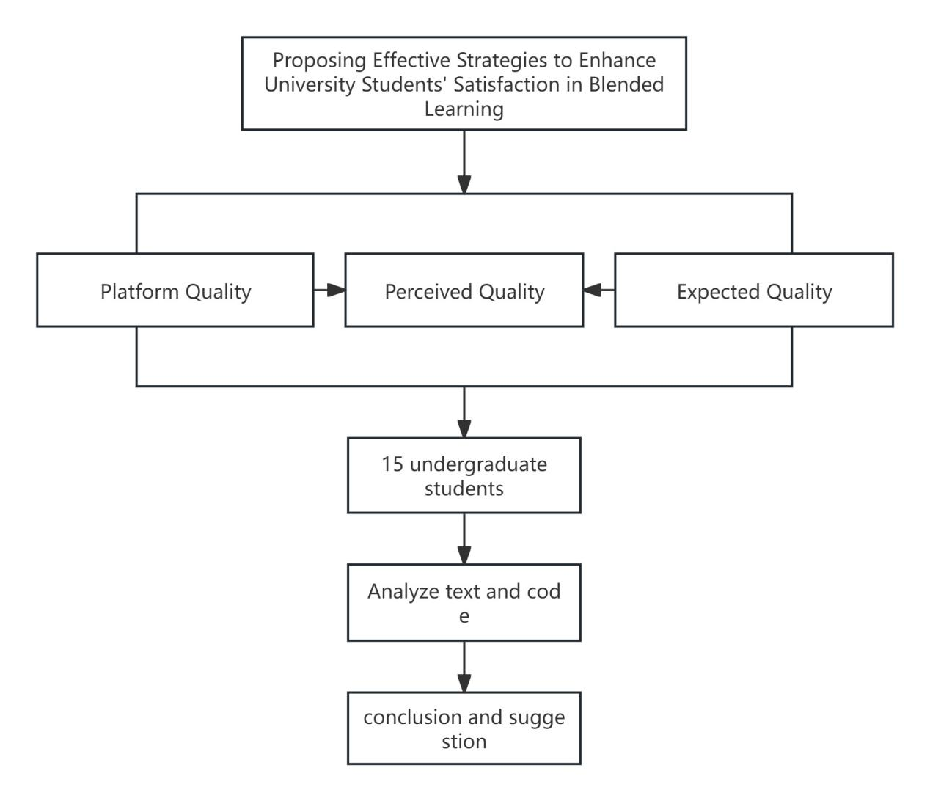
Figure 1 Conceptual framework
Note: Constructed by the researcher
Methodology
This paper adopts qualitative research methods, i.e., literature analysis, semi-structured interviews, and textual analysis. Firstly, this study clarifies the factors influencing Chinese college students' satisfaction with blended learning through the literature analysis method. Subsequently, some students were interviewed based on semi-structured interviews, and finally, the interview data were coded, analyzed, and conclusions were drawn using content analysis.
- Selection of Interview Subjects
In this study, the interview subjects were mainly selected from the current students of four universities in China's Sichuan province from the class of 2023 to the class of 2021. Firstly, we exclude students who have not participated in Blended Learning, and secondly, we select students with different genders and different grades, to choose diverse interview subjects as much as possible, and to ensure a balanced structure to achieve the scientific nature of the interview results.
The practice of this interview is from January 2024 to March 2024, the final actual participation in the interview of a total of 15 subjects, including 8 males and 7 females, aged between 19-22 years old; 8 students in grades 2, 5 students in grade 3, 2 students in grade 4.
2. Determining the interview process
The semi-structured interview method is used to interview students, and the purpose of the interview has the following two aspects: firstly, to understand the current situation of Blended Learning development in colleges and universities through the interviewee's learning experience of Blended Learning, and secondly, to analyze what the influencing factors of students' satisfaction in Blended Learning are based on the theory of satisfaction. The interview outline was first selected from three undergraduate students, after the questions were modified and improved to form the interview outline.
3. Data analysis method
After the interview, the relevant records are timely sorted and analyzed, and the relevant conclusions are finally refined through repeated reading, analysis, reflection, coding, and classification.

Results
1. Factors affecting college students' satisfaction with blended learning
1.1 Platform quality will have an impact on the satisfaction of Blended Learning
In the interviews, it was found that the quality of the online teaching platform in Blended Learning is a key factor in students' evaluation of their satisfaction with Blended Learning, specifically, system stability, ease of use of the platform, and information relevance are the three main dimensions that constitute the quality of the platform, and they have a significant impact on students' satisfaction. Students generally reported that a stable and responsive platform significantly enhanced their learning experience. On the contrary, frequent technical glitches and slow loading times interrupt the learning process, leading to student frustration and dissatisfaction. Meanwhile, the ease of use (aesthetics) of the learning platform is an important factor in the ability to quickly find the courses and materials they need during the learning process, and good ease of use enhances students' trust in the platform, thus increasing their satisfaction. Meanwhile, the high-quality teaching resources and information provided in the platform a key factors for them to choose and persist in using the platform, and the updating speed and usefulness of the content are also important factors affecting students' satisfaction.

Table 1 Platform Quality Interview Codes and Keywords
Encodings | Interview Keywords
System Stability | Login, load speed, run speed, and cross-platform
Platform Ease of Use | User support, UI design, system guidelines
Information Relevance | Suitable for self-study, course relevance, update speed, and push

In summary, platform quality is an important factor in blended learning satisfaction. A high-quality platform can provide a stable, efficient, and rich learning experience, thus increasing student satisfaction.
1.2 Expected quality affects satisfaction with blended learning
Interviews revealed that the quality of students' expectations of teaching significantly influenced their satisfaction with blended learning. Expected quality involves students' prejudgements about the effectiveness of teaching and learning, including expectations about content, teaching methods, and learning outcomes. In terms of content expectations, students expected blended instruction to provide high-quality learning materials that were closely related to real-world needs. In the interviews, students generally indicated that their satisfaction with teaching would be higher if the content matched their career plans and academic interests. In terms of teaching method expectations, students' expectations included interactivity, flexibility, and personalization. They expect Blended Learning to provide diverse learning modes, such as online discussions, video lectures, and interactive learning activities, to meet the needs of different learning styles. In terms of learning outcome expectations, students' expectations of learning outcomes relate to specific skills and knowledge that can be acquired through blended learning. They expect these skills and knowledge to help them succeed in their future academic or professional careers.

Table 2 Expected Quality Interview Codes and Keywords
Encodings | Interview Keywords
Teaching content expectations | Content Practicality, Course Introduction, Fit, Contextualization
Teaching methodology expectations | Interactive, flexible, personalized
Learning outcome expectations | Skill Acquisition, Knowledge Application, Career Preparation

The results of the study indicate that the quality of students' expectations largely determines their satisfaction with blended instruction. When blended instruction meets or exceeds students' expectations, their satisfaction increases significantly.
1.3 Perceived quality affects satisfaction with blended learning
During the interviews, it was concluded that students' perceived quality of teaching significantly affects their satisfaction with blended learning. Perceived quality involves students' overall evaluation of teaching and learning, including their perceptions of the dimensions of course design, the instructor's teaching ability, and evaluation methods. In terms of perceived course design, students expected blended instruction to provide a structured and engaging course design. During the interviews, students generally indicated that good course design could improve their learning efficiency and satisfaction. In terms of perceived instructor teaching ability, as one of the equally critical factors, students expected instructors to be proficient in using blended learning methods and to provide effective guidance and feedback. In terms of perceived assessment methods, students believe that diversified assessment methods can reflect their learning outcomes more comprehensively and increase their satisfaction with teaching.

Table 3 Perceived Quality Interview Codes and Keywords
Encodings | Interview Keywords
Course Instructional Design | Structured, attractive, logical
Teachers' pedagogical skills | Skilled, effective instruction, in-depth
Course Evaluation Methods | Diversity, full reflection, equity

In summary, students' perceived quality largely determines their satisfaction with blended instruction. When blended instruction meets or exceeds students' perceived quality, their satisfaction increases significantly.
2. Strategies to enhance college students' satisfaction with Blended Learning and learning
2.1 Convenient, easy-to-use, and highly intelligent Blended Learning platforms should be selected or developed to provide technical support for teachers and students in blended environments. Ideal teaching platforms should have ease-of-use and multi-device compatibility, and be able to seamlessly meet different teaching and learning needs. The platform should support a variety of teaching and learning activities, such as synchronous and asynchronous communication, resource sharing, online assessment and feedback, and customization of personalized learning paths. In addition, the platform should be able to collect and analyze learning data to help teachers understand students' learning progress and effectiveness, to provide more targeted guidance and support.
2.2 Efforts are made to improve teachers' teaching skills and ability to utilize technology in the Blended Learning environment, optimize course teaching design, carefully design course content, and organically combine classroom teaching with online teaching. For example, the course content can be divided into several topics, and each topic is explained through a combination of online teaching and classroom teaching. In this process, it is necessary to provide rich online teaching resources, including teaching videos, PPTs, reference books, etc., so that students can study before class and review after class. Secondly, in offline classroom teaching, teachers need to focus on interaction with students, guide students to actively participate in the discussion, deepen their understanding and mastery of knowledge, and establish a timely feedback mechanism to collect students' suggestions and opinions, to adjust the teaching strategy to better meet students' learning needs. Teachers should also receive regular technical training and pedagogy seminars to keep their teaching methods modern and effective.
2.3 Establish a multi-dimensional teaching and evaluation model to support innovative and interactive teaching and learning activities, including the use of Open Educational Resources (OER), virtual language project laboratories, language intelligence simulation tools, and the promotion of cross-disciplinary collaborative teaching and learning projects, etc., to enrich the course content of blended learning and to increase the practicability of learning. The evaluation method should be changed from a single test result to a multi-dimensional assessment, including project assignments, peer assessment, self-evaluation, and online interaction, to reflect students' learning effectiveness more comprehensively. This diversified evaluation system can not only stimulate students' learning motivation but also help them better adapt to future learning and working environments.

Discussion
By analyzing the above, it was found that the factors influencing student satisfaction in blended learning are multidimensional and interrelated. The quality of the platform, the quality of expectations, and the quality of perceptions, each of which shapes students' overall satisfaction with blended learning. These findings reveal the complexity of student experience in blended learning and emphasize the need for universities to consider multiple aspects of instructional design, technology platforms, and instructional resources when implementing blended learning to enhance the quality of instruction and students' learning experience. These findings echo the ideas in the existing literature as Chan (2023), in an empirical study of student satisfaction and its influencing factors in Blended Learning, investigated that course instructional design, instructor's teaching ability, teaching resources and content, platform technical support, and diversified evaluations are the key factors affecting student satisfaction. Chai (2021) also found that teacher image, perceived quality (software and hardware), and perceived value have a direct positive effect on student satisfaction. In their study on the chain mediating role of learning alienation and learning engagement. Wu & Zhang (2024) found that learning support services influence blended learning satisfaction by affecting feelings during the learning process. These studies provide valuable references to guide colleges and universities to enhance student satisfaction and learning outcomes more effectively in blended learning practices.
Conclusion
In this study, through an in-depth analysis of the factors influencing college students' satisfaction with blended learning, we obtained the following key findings:
1. Platform quality was found to be a significant factor influencing student satisfaction. Specifically, a stable, easy-to-use, and informationally relevant online teaching platform had a significant positive impact on student satisfaction. Students generally agreed that a responsive, user-friendly, and resourceful platform could greatly enhance their learning experience.
2. The study found that expected quality also had a significant impact on student satisfaction. Students' expectations of content, teaching methods, and learning outcomes that are met or exceeded will significantly increase their satisfaction with blended learning. This suggests that colleges and universities must fully consider and meet students' expectations when designing blended learning courses to enhance teaching quality and learning experience.
3. The study found that perceived quality is another key factor affecting student satisfaction. Students' perceptions of course design, teachers' teaching ability, and evaluation methods directly affect their overall evaluation of blended learning. A structured and attractive course design, as well as teachers' efficient teaching ability and fair evaluation methods, can significantly enhance student satisfaction.

Recommendation
Based on the findings of this study, the following recommendations are made for both theoretical and applied levels:
1. Theoretical Recommendations
1.1 Recommendations for the current status of this study: interdisciplinary research in pedagogy, psychology, and information technology is encouraged to explore in depth the influence mechanism of student satisfaction in Blended Learning to construct a more comprehensive theoretical model.
1.2 Suggestions for policies: Educational policymakers should pay attention to the construction and maintenance of Blended Learning platforms and formulate relevant policies to support colleges and universities in terms of technological inputs, teacher training, curriculum development, etc., to ensure the quality and effectiveness of Blended Learning.
2. Application Suggestions:
2.1 Colleges and universities should apply the results of the study to teaching practice to enhance the effectiveness of Blended Learning and student satisfaction by optimizing the online platform, enriching teaching resources, and improving teaching methods.
2.2 Enhance the professional development of teachers in the Blended Learning environment, especially to improve their ability to use information technology for teaching design and implementation.
2.3 Future research can further explore the impact of blended learning on students' learning outcomes, including knowledge acquisition, skill enhancement, and problem-solving ability. Consideration should also be given to taking into account more individual student differences, such as learning styles, motivation, and prior knowledge, and examining how these factors affect satisfaction and learning outcomes of blended learning.
Through the implementation of these recommendations, the development of blended learning can be further promoted to improve the quality of teaching and learning, enhance students' learning satisfaction, and ultimately achieve the optimization of educational goals.

References
Cardozo, R. N. (1965). An experimental study of customer effort, expectation, and satisfaction. Journal of Marketing Research, 3, 244–249.
Chai, S. (2021). A study on student satisfaction and influencing factors of blended learning: A case study of Peking University teaching network. China Distance Education, 6, 32–38, 79.
Chan, Y.-T. (2023). Construction and implementation of a blended learning community for college English. Contemporary Foreign Language Studies, 23(5), 141–147.
Dai, X. L., Kokka, & Liu, L. (2017). An empirical study on the factors influencing MOOC learners' satisfaction: A structural equation analysis based on the questionnaire of Chinese university MOOC learners. Modern Distance Education, 2, 17–23.
Liu, W., & Yang, X. (2017). A preliminary study of customer satisfaction index (CHE-CSI) modeling in Chinese higher education. Northeastern University (110004).
Liu, X. (2023). Trends, hot spots, and prospects of domestic blended learning research in the past ten years: A visual analysis based on CiteSpace knowledge mapping. English Teacher, 22, 40–44.
Martensen, A. L., Grønholdt, L., & Kristiansen, P. (2000). Customer satisfaction and loyalty: The role of customer expectations and perceived quality. Total Quality Management, 11(8), 1007–1020.
Wang, F. (2018). Analysis of influencing factors of college students' teaching satisfaction based on hierarchical linear modeling. Fudan Education Forum, 16(1), 48–53.
Wu, B., & Zhang, M. (2024). The effects of learning support services on blended learning satisfaction: The chain mediation of learning alienation and learning engagement. Teaching and Learning in Elementary School Subjects, 2024, 1003–0964.
Zhang, B., & Lin, J. B. (2014). Empirical analysis of influential factors on university teaching satisfaction: Based on the perspectives of students' expectations and students' perceived quality. Fudan Education Forum, 12(4), 59–65.
Zhang, B., & Yang, B. C. (2015). Research on the influencing factors of bilingual teaching satisfaction and loyalty in colleges and universities: An empirical analysis based on structural equation modeling. Fudan Education Forum, 13(3), 53–59.

