THE INFLUENCES OF INFORMATIZATION LEADERSHIP ON MANAGEMENT
EFFECTIVENESS: A CASE OF ART MAJORS COLLEGES
AND UNIVERSITIES IN SHANGHAI

Lyu Shuai
Prapatpong Senarith
Sukhum Moonmuang
Educational Administration, Faculty of Education,
Bankokthonburi University
สาขาวิชาการบริหารการศึกษา คณะศึกษาศาสตร์ มหาวิทยาลัยกรุงเทพธนบุรี
E-mail: 1664856626@qq.com
Received : 24 September 2022
Revised : 17 June 2023
Accepted : 17 June 2023

ABSTRACT
The objectives of this research were: (1) To study the influences of informatization leadership of art-major teachers in Shanghai colleges and universities on management effectiveness. (2) To further decompose the influences of informatization leadership, by taking into account teachers’ organizational commitment and external factors of colleges and universities in Shanghai city. (3) To evaluate the model fit with empirical data.
In this quantitative research, a stratified multi-stage sampling method was used to proportionally select 200 teachers from various art majors in colleges and universities located in Shanghai of China. Data collected via email and online platforms using Likert 5-point test questionnaires. Descriptive statistics, confirmatory factor analysis and structural equation modelling were used in data analysis.
The main research results were as follows: (1) The informatization leadership of art teachers in Shanghai colleges and universities has a significant impact on management effectiveness. Informatization leadership can promote the improvement of management efficiency and is more conducive to the development of art-major teachers in Shanghai colleges and universities; (2) By taking into account teachers’ organizational commitment and selected external factors, the data showed that external factors significantly influenced informatization leadership and management effectiveness; and (3) The structural equation model in the study fitted well with empirical data.
Keywords: Informatization leadership, Art Majors, Management Effectiveness, Higher education

1. Introduction
Based on the perspective of the current educational management efficiency reform, the research method of empirical questionnaire survey and analysis is adopted to develop the "Informatization Leadership Evaluation Tool for Colleges and Universities” and build a teacher informatization leadership model in educational management effectiveness. With the development of globalized information technology and the intervention of the Internet, we must grasp the development trend of the current era, constantly update the educational management concept, innovate the educational management mechanism, and improve the educational management efficiency through the combination of the informatization education model and information technology. The development of a good realization of the long-term goals of education management. However, the related research on informatization leadership in China started relatively late, and the research level is relatively simple.
Through this research, the demonstration relationship between informatization leadership and management effectiveness was combined in universities in the art major of Shanghai, and then continue to build a new connotation of leadership that adapts to the background of informatization education, so that the education management of art majors in Shanghai undergraduate colleges and universities has been systematically developed.

2. Research Questions
The following questions were set to guide this study:
1. How does informatization leadership affect the effectiveness of art major management effectiveness?
2. What are the factors that influence teachers' organizational commitment by informatization leadership?
3. Does teachers’ organizational commitment affect art major management effectiveness?
4. What are the external factors in colleges and universities on informatization leadership?
5. What positive effects do external factors in colleges and universities have on management effectiveness?
6. How do external factors in colleges and universities affect teachers’ organizational commitment?
7. How external factors in colleges and universities affect management effectiveness effects through informatization leadership?
8. How external factors in colleges and universities affect management effectiveness through informatization leadership and teachers' organizational commitment?
9. How informatization leadership affects management effectiveness through teachers' organizational commitment?

3. Research Objectives
The purposes (objectives) of this research were:
1. To study the influence of informatization leadership of art major teachers in Shanghai colleges and universities on management effectiveness.
2. To decompose the influences of informatization leadership, by taking into account of teachers’ organizational commitment and external factors of colleges and universities in Shanghai city.
3. To evaluate the model fit with empirical data.

4. Research Hypotheses
H1: Informatization leadership has a positive impact on management effectiveness.
H2: External factors in colleges and universities have a positive impact on management effectiveness.
H3: Teachers' organizational commitment has a positive impact on management effectiveness.
H4: External factors in colleges and universities has positive affect informatization leadership.
H5: Informatization leadership has a positive impact on teachers' organizational commitment.
H6: External factors in colleges and universities have direct effects on teachers' organizational commitment.
H7: External factors in colleges and universities affect management effectiveness through informatization leadership.
H8: External factors in colleges and universities affect management effectiveness through informatization leadership and faculty organizational commitment.
H9: Informatization leadership affects managerial effectiveness through teachers' organizational commitment.

5. Research Method
The data were collected through questionnaires and interviews using quantitative research methods. This study adopts the following methods: literature analysis method; survey method; quantitative analysis method. After the questionnaire was evaluated by experts, the final questionnaire was determined and the questionnaire was distributed. 225 questionnaires were distributed by e-mail, and 200 valid questionnaires were recovered, and the availability rate of the questionnaires was 88%.as shown in Table 1.

Table 1: Population Range and Sample Size

No | Name of Institution | Major/Faculty | Collect Sample Size
1 | University Of Shanghai for Science and Technology | School of Creativity and Art | 18
2 | Tongji University | College of Arts & Media | 16
3 | East China University of Science and Technology | School of Art Design and Media | 16
4 | Shanghai University | Shanghai Academy of Fine Arts | 18
5 | Donghua University | College of Fashion and Design | 16
6 | Shanghai Normal University | Fine Arts College | 16
7 | Shanghai University of Engineering Science | School of Art and Design | 18
8 | Shanghai Business School | Art Design College | 16
9 | Shanghai Second Polytechnic University | College of Applied Art& Design | 16
10 | Shanghai Maritime University | XuBeihong Art Academy | 16
11 | East China Normal University | College of Fine Arts | 18
12 | Shanghai Theatre Academy | —— | 16
Total 12 |  |  | 200

6. Research Results
1) Sample characteristics

Table 2: Frequencies and percent of personal characteristics of respondents

Variables | level | n | %
gender | male | 98 | 49.0
 | female | 102 | 51.0
age | under 30 | 55 | 27.5
 | 31-49 years old | 132 | 66.0
 | over 50 | 13 | 6.5
education background | Bachelor | 41 | 20.5
 | Master | 105 | 52.5
 | PhD | 54 | 27.0
teaching age | 1-5 years | 78 | 39.0
 | 6-10 years | 54 | 27.0
 | 11-15 years | 68 | 34.0
specialized | Design | 123 | 61.5
 | Fine Arts | 48 | 24.0
 | Theory of Art | 9 | 4.5
 | Drama and Film | 8 | 4.0
 | Music and Dance | 12 | 6.0
job title | Teaching Assistant | 32 | 16.0
 | Lecturer | 88 | 44.0
 | Associate Professor | 35 | 17.5
 | Professor | 11 | 5.5
 | Other | 34 | 17.0
total |  | 200 | 100.0

Data analysis in Table.2 showed that 200 valid questionnaires were obtained, and the availability rated of the questionnaires was 88%. The basic values of the sample data were analyzed by SPSS software. The analysis showed that 49% males and 51% females. The proportion of age is that 30-49 years old (66%) accounted for a large proportion. accounted for a small proportion. Among the surveyed educational backgrounds, masters (52.5%) accounted for a higher proportion, while others accounted for a lower proportion. In terms of the proportion of teachers' working years, the proportion of 1-5 years of work experience (39%) was relatively high. From the professional point of view, design majors accounted for the largest proportion of 61.5%, and other majors accounted for a small proportion. In terms of the professional titles of the respondents, lecturers accounted for the highest proportion (44%), and other categories accounted for a smaller proportion.
2) Descriptive statistics of variables
The statistics to be used in this analyzed were, means (X), standard deviation (S.D.), and the coefficient of variation (%CV), skewness, kurtosis, Shapiro-Wilk W test, and Mardia’s coefficient. Results of data analyses were as in Table 3.

Table 3: The Means, Standard Deviations, and the Percent of Coefficient of Variation of All Observed Variables.

Observed Variables |  | S.D. | %CV | SK | KU | Shapiro-Wilk | p-value
x1 | 3.905 | 0.678 | 17.371 | .031 | -.623 | .953 | <.001
x2 | 3.997 | 0.638 | 15.977 | -.088 | -.337 | .945 | <.001
x3 | 3.935 | 0.683 | 17.368 | -.212 | -.146 | .945 | <.001
x4 | 3.923 | 0.693 | 17.680 | -.218 | .102 | .934 | <.001
x5 | 4.168 | 0.622 | 14.946 | -.353 | .458 | .905 | <.001
x6 | 4.150 | 0.584 | 14.085 | -.691 | .844 | .912 | <.001
x7 | 4.069 | 0.707 | 17.397 | -.285 | .008 | .915 | <.001
x8 | 3.631 | 0.893 | 24.593 | -.655 | .947 | .945 | <.001
x9 | 4.128 | 0.669 | 16.226 | -.279 | -.266 | .912 | <.001
y1 | 4.124 | 0.563 | 13.661 | -.001 | -.435 | .933 | <.001
y2 | 4.107 | 0.553 | 13.484 | -.276 | .166 | .939 | <.001
y3 | 3.911 | 0.727 | 18.609 | -.224 | -.547 | .945 | <.001
 | Mardia’s coefficient 85.198
Note: x1: Informatization Leading Ability. x2: Informatization Culture Construction Ability. x3: Informatization Technology Application Ability. x4: Informatization Vision .x5: Economic Factors. x6: Policy Factors. x7: Opportunity Commitment. x8: Economic Commitment. x9: Normative Commitment. y1: Work Performance. y2: Interpersonal Relationship. y3: Organizational Structure.

The descriptive analysis resulted for each variable were shown in the table above. As can be seen from the chart data, the average value of each variable was between 3.631 and 4.168. Overall, subjects' perception of each variable was at a high level. From the perspective of the percentage of deviation coefficient CV, the value was between 13.4% and 24.5%, indicating that the data was not concentrated and the deviation was large.

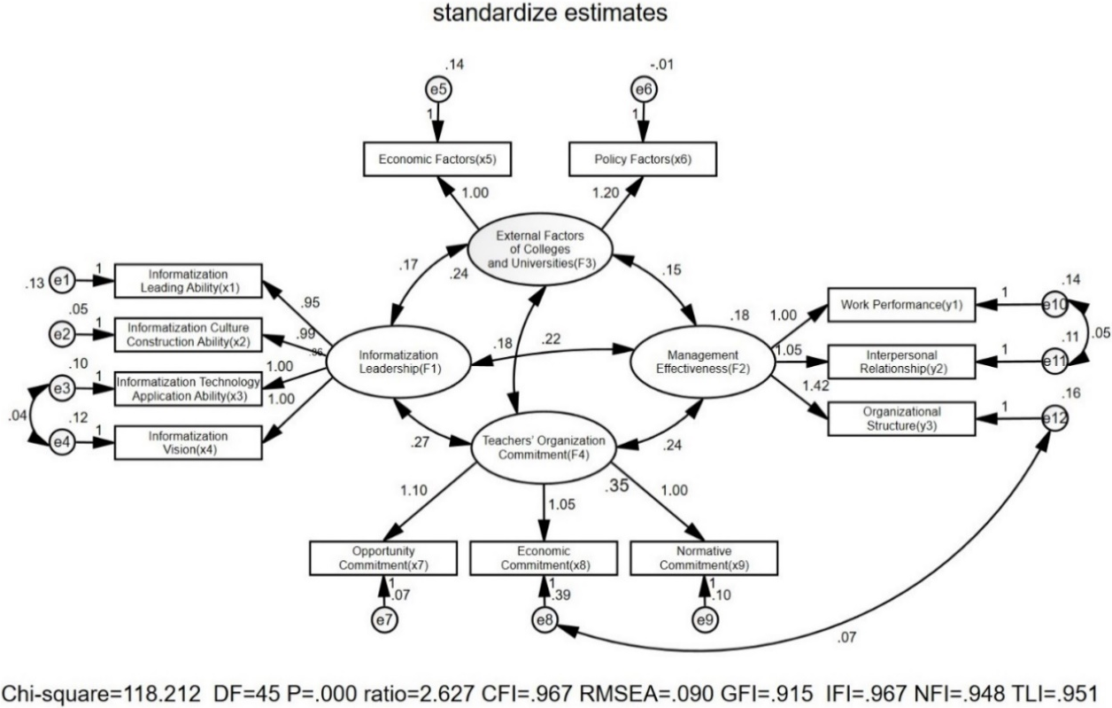
Measurement model

Figure 1: The Measurement Model of Four Latent Variables and Their Intercorrelation
in Standardized Format, and the Model Fit Indexes.
If the model fit index reaches the recommended value, it meant that the model fits good, indicating that the hypothetical model was supported by the data .The fit of the model was verified by confirmatory factor analysis, and it was found that all values of the measurement model were in line with the standard, including CMIN/DF=2.637(CMIN/DF＜3), Data conforms to standards .NFI=0.948, IFI=0.967, TLI=0.919, CFI=0.951, The average data was greater than 0.9 in line with the standard. Indicating the fit of the model Degree is good. RMSEA=0.090 (less than 0.08) was acceptable. It can be seen that the overall fit index of the model had reached the recommended value, indicating that the constructed model was supported by practical data (Joel & Collier, 2020: 221-239).

3) Reliability and validity

Table 4: The Composite Reliability (CR), the Average Variance Extracted (AVE) the Maximum Shared Variance (MSV), the Maximum Reliability (MaxR(H)), and the Latent Variables Intercorrelation with Square Root of AVE at the Diagonal. (Validity Analysis).

Latent variables | CR | AVE | MSV | MaxR(H) | F2 | F3 | F1 | F4
Inf-Lea | 0.935 | 0.782 | 0.756 | 0.942 | 0.884
Ext-Fac | 0.902 | 0.824 | 0.498 | 1.023 | 0.585*** | 0.908
Man-Eff | 0.841 | 0.639 | 0.880 | 0.846 | 0.870*** | 0.706*** | 0.799
Tea-Org | 0.880 | 0.712 | 0.880 | 0.912 | 0.756*** | 0.631*** | 0.938*** | 0.844
Note: *** means P<0.001: CR=composite reliability, AVE=average variance extracted, MSV=maximum shared variance, MaxR(H) = maximum reliability; Inf-Lea (F1) = Informatization Leadership, Man-Eff (F2) = Management Effectiveness, Tea-Org (F4) = Teacher’s Organizational Commitment, Ext-Fac (F3) = External factors of the colleges and universities

Reliability and validity were mainly determined by MaxR (H) and MSV. In general, the MaxR(H) value of each variable should be greater than their CR value, while the MSV value of the variables should be less than their AVE value (Fornell & Larcker, 1981). The reliability and validity analysis were showed in Table 4.6. The MaxR(H) values were 0.942, 1.023, 0.846, 0.912. The MaxR(H) values were all greater than the CR values, which were in line with the standard. MSV values were 0.756, 0.498, 0.880,0.880. AVE values were 0.782, 0.824, 0.639, 0.712, and variables F1 and F3 were consistent (Fornell & Larcker, 1981).
In this model we used the composite reliability to assessed the measurement model reliability with the cut off criteria of .70 (Hair, et. al, 2017). Data analysis in table 4.6 showed that the CR values are 0.935, 0.902, 0.841, and 0.880. It showed that the data had good reliability.
4) Hypothesis testing
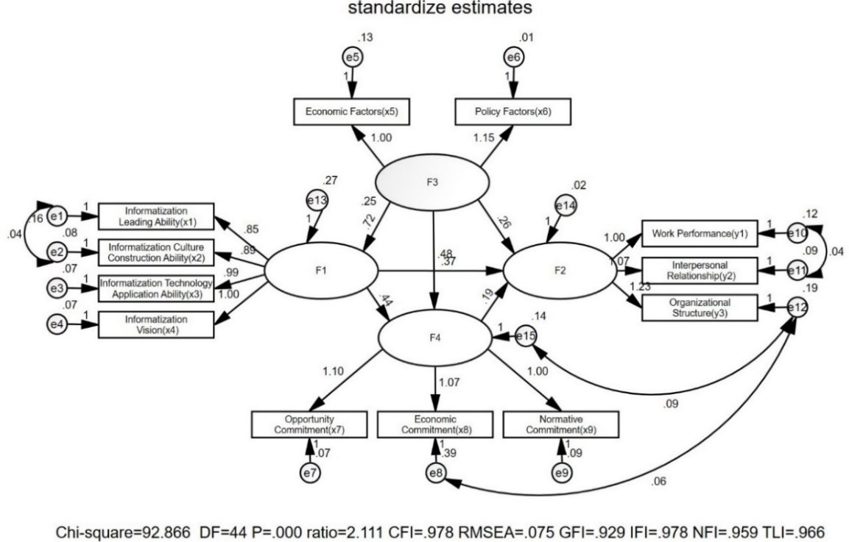

Figure 2: Structural Equation Models and Model Evaluation

5) Direct effects
Table 5: The hypotheses testing

Effects | Estimate | Standardized | S.E. | z-test | P-value | Hypothesis
Inf-Lea→Man-Eff | 0.369 | 0.534 | 0.051 | 7.176 | *** | H1
Ext-Fac→Man-Eff | 0.259 | 0.297 | 0.058 | 4.438 | *** | H2
Tea-Or→Man-Eff | 0.188 | 0.255 | 0.065 | 2.873 | .004 | H3
Ext-Fac→Inf-Lea | 0.719 | 0.569 | 0.088 | 8.130 | *** | H4
Inf-Lea→Tea-Org | 0.442 | 0.471 | 0.064 | 6.859 | *** | H5
Ext-Fac→Tea-Org | 0.481 | 0.405 | 0.079 | 6.092 | *** | H6
Note: Inf-Lea=Informatization Leadership, Man-Eff=Management Effectiveness, Tea-Org=Teacher’s Organizational Commitment, Ext-Fac= External factors of the colleges and universities.; *** means P<0.001.

According to the analysis resulted in Table.5, the significant results (P values) of the six direct hypotheses in this study were all less than 0.05, indicating that the six direct hypotheses in this study were all valid (Arbuckle J., 2008: 72-79).
6) Indirect effects
Table 6: The Effect Decomposition in→ the Indirect Effects.

Hypothesis | Indirect path | Estimate | Lower | Upper | P
H7 | Ext-Fac→Inf-Lea→Man-Eff | .2655 | .1703 | .4142 | .0006
H8 | Ext-Fac→Inf-Lea→Tea-Org →Man-Eff | .0598 | .0033 | .1528 | .0693
H9 | Inf-Lea →Tea-Org→ Man-Eff | .0832 | .0057 | .2055 | .0713
Note: Inf-Lea=Informatization Leadership, Man-Eff=Management Effectiveness, Tea- Note: Org=Teachers’ Organizational Commitment, Ext-Fac= External factors of the colleges and universities; P = probability to commit type-1 error.

The mediating effect of the model was tested using the Bootstrap method. As can be seen from Table.6, the significant results (P value) of H7, H8 and H9 in this study, only H7 was less than 0.05, among which the indirect effect of Ext-Fac on Man-Eff through Inf-Lea was 0.2655, while 95 % confidence interval [0.1703-0.4142] excluding 0. This suggested that Inf-Lea had a significant mediating effect on Ext-Fac and Man-Eff, thus H7 holds, the assumptions of H8 and H9 were not established. (Gaskin & Lim, 2018).

7. Conclusion, Discussion and Recommendations
The survey sample of this research was art major teachers in Shanghai universities. The population sample was determined by stratified multistage random sampling and conditional sampling to determine the sample size 200. The Likert (5-level) rating scale questionnaire prepared by the researcher was sent to the interviewees. The statistics used in the data analysis were descriptive statistics, confirmatory factor analysis (CFA) and structural equation modeling (SEM).
Through the above research, it is concluded that (1) the informatization leadership of art major teachers in Shanghai colleges and universities had a positive impact on management effectiveness. (2) Teachers' information leadership will be affected by external factors in colleges and universities, and informatization leadership will had a positive impact on teachers' organizational commitment. (3) The model fits the empirical data effectively.
This research provides some inspiration and reference for the management effectiveness of art major teachers in colleges and universities in Shanghai. Through the continuous improvement of the development of informatization leadership, it will definitely have a long-term impact on the management effectiveness of art major teachers. The following points are worthy of consideration in follow-up research and further study.
(1) Recommendation for policy formulation
Promoting the informatization of art majors in colleges and universities is the common responsibility of the government, colleges and universities, college leaders and teachers. The ability of college teachers to used information technology to process information, including consciousness, thought and technology. Informatization leadership in the field of art majors in colleges and universities will enhance the diversification of art education and expand new ideas for art professional education.
(2) Recommendation for practical application
Through the above content, the relationship between the informatization leadership and management effectiveness of art majors in colleges and universities is analyzed in detail. The external factors include: the policy development system and economic input indicators issued by the government or local management departments, and each college will be potentially restricted by external factors.How to make art teachers understand-accept-learn-apply informatization leadership requires a long period of adaptation. After analyzing the influencing factors, it will enter a relatively important practice stage.
(3) Recommendation for Further Research
Under the background of the development of educational informatization, the fundamental goal of college art major teachers to develop informatization leadership is to expand the management efficiency in the network age. Based on the interpretation of the characteristics of informatization leadership, we found that art teachers and informatization leadership will be a good combination, and art teachers will be improved in different aspects.
BIbliography
Arbuckle, J. (2008). Amos 17.0 user's guide. 72-79.
Fornell, C., & Larcker, D. (1981). Evaluating structural equation models with unobservable variables and measurement error. Journal of Marketing Research, 337-346.
Gaskin, J., & Lim, J. (2018). Indirect Effects. AMOS Plugin: Gaskination’s StatWiki.
Hair, et. al. (2017). Multivariate Data Analysis. 8th ed. United Kingdom: Cengage Learning EMEA.
Joel, E., & Collier. (2020). Applied Structural Equation Modeling Using AMOS. 221-239.

